ECSE 415 Project Report

Miao Zhao, Ryan Ren, Yike Liu, Chianyu Liu, Shehryar Haider

2016.4.15

**Q1**

All images of subject #31 (*YongminYGrey*) from the QMUL Multiview Face Datasize are shown below (Figure 1):

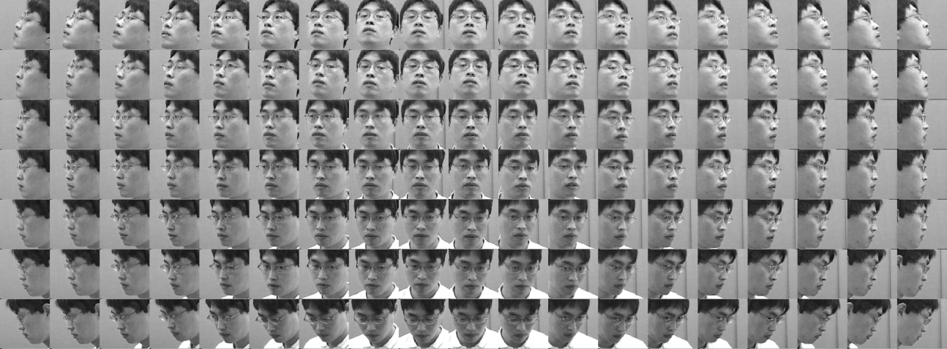

Figure 1

**Q2**

All series #2 images of subject #15 (Person 15) from the Head Pose Image Database are shown below (Figure 2):

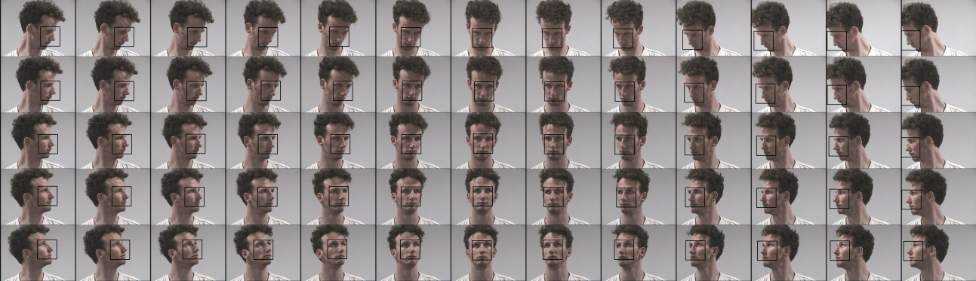

Figure 2

**Q3**

Average reconstruction error for the *training sets* versus the number of Eigenfaces (Figure 3):

Figure 3

Average reconstruction error for the testing sets versus the number of Eigenfaces (figure 4):

Figure 4

Based on the results of showing the average reconstruction errors for training and testing sets, we get the optimal number of Eigenfaces is around **100**.

**Q4**

The mean image of the training set and the first 10 Eigenfaces are shown below (Figure 5&Figure 6):

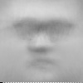

Figure 5

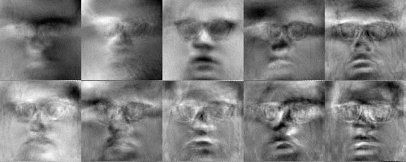

Figure 6

**Q5**

Test samples (Figure 7) and train samples (Figure 8):

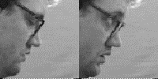

Figure 7

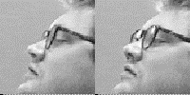

Figure 8

Comparison of original and reconstructed versions of each images:

|  |  |  |  |
| --- | --- | --- | --- |
| original  testSample1 | reconstructed  testSample1 | original  testSample2 | reconstructed  testSample2 |
| original  trainSample1 | reconstructed  trainSample1 | original  trainSample2 | reconstructed  trainSample2 |

(Format of combined images below)

Eigenvector = 1 (Figure 9):

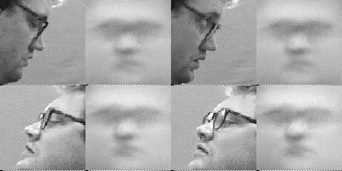

Figure 9

Eigenvector = 5 (Figure 10):

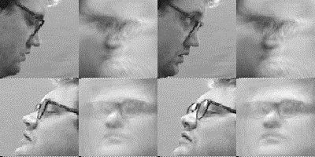

Figure 10

Eigenvector =100 (Figure 11):

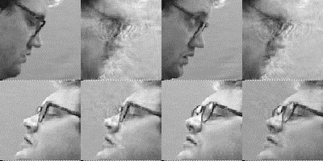

Figure 11

**Q6**

The plot of average recognition rate versus the number of Eigenfaces for the number of eigenvectors: {1,2,5,10,20,50,100,200,500,1000,2000,3000,𝑎𝑙𝑙} is shown below (Figure 12):

Figure 12

Based on the results and considering our optimal choice in Q3(which is 100), the optimal number of Eigenfaces is **100**.

**Q7**

Correctly classified training and testing images (Figure 13):



Figure 13

Misclassified training and testing images (Figure 14):

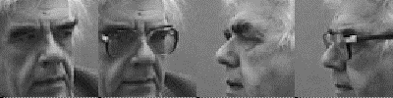

Figure 14

**Q8**

Take 100 as our optimal number of eigenvectors, the average recognition rate of the Eigenfaces is **0.824**.

When characterizing the type of differences which occur when matching two images in a face recognition task, take s as the number of subjects in the training set , and I as an image projected into the Eigenspace. Using Bayes rule:

Where the priors p(S) can be set to reflect specific operating conditions (e.g., number of test images vs. The size of the database) or other sources of a prior knowledge regarding the two images being matched. The final result of our probabilistic Eigenfaces method which performs 7-fold cross validation shows that the recognition rate is around **0.84** and is similar to the average recognition rate of the Eigenfaces.

**Q9**

Average recognition rate versus the number of pyramid levels L = {0,1,2,3} (Figure 15):

Figure 15

Based on the result, our optimal number of pyramid levels is 1.